Geethanjali Vivekanandan

Abstract

Analysis of predictive relationship between the Istanbul Stock Exchange National and seven other international stock market indices.

MATH -564-FINAL PROJECT

A20405203

**Analysis of predictive relationship between the Istanbul Stock Exchange National and seven other international stock market indices.**

**Problem Statement:**

* 1. Literature

We know that stock market is very volatile in nature and is dependent on multiple factors internally and externally. Globalization of the forecasting stock market movements has made forecasting difficult. Because of the inter-dependency of stock markets with each other we should take into consideration the effect of this dependency to make accurate forecasts. This interdependency has especially large impact on stock market indices in developing countries.

1.2 Objective

In this paper we are analyzing the predictive relationship between the stock-markets and understand which impacts the Istanbul stock exchange the most.

Various data mining techniques have been implemented in the recent past to predict the behavior of stock market. Every method tries to fit a model to the training data to predict the future. The accuracy of prediction depends on the model fitting. We propose a linear model for stock market prediction and further elaborate on improving the fit of the model. As conclusion we will try to understand why this interdependency exists.

**Analysis process:**

2.1 Data Description

We refer to the Istanbul Stock Exchange Data Set which includes returns of Istanbul Stock Exchange and seven other international indices: SP (Standard & Poor’s), DAX (Stock market return index of Germany), FTSE (Stock market return index of UK), NIKKEI (Stock market return index of Japan), BOVESPA (Stock market return index of Brazil), EU (MSCI European index), and EM (MSCI emerging markets index).

2.1.1 Istanbul stock exchange National 100 index

The Istanbul Stock Exchange National 100 Index constitutes of national market enterprises resulting into a capitalization-weighted index. The components of National 100 Index are chosen on pre-determined criteria directed for the enterprises to be included in the indices. The base date is January 1986 and base value is 1 for the TL based price.

2.1.2 Istanbul stock exchange Standard 500 return index

The performance of domestic brands is measured on a capitalization-weighted index of 500 stocks. It evaluates the performance by measuring the changes in the aggregate market value of 500 stocks representing important industries. The index was derived with a base level of 10 for the 1941- 43 base periods.

2.1.3 Stock market return index of Germany

The German stock index comprises of 30 important German enterprises trading on Frankfurt Stock. The growth of these is measured on by the operator of Xetra in terms of order volume and market capitalization. The DAX index’s (German benchmark) performance is represented by the L-Dax index after the electronic trading is closed.

2.1.4 Stock market return index of Japan

Tokyo Stock Price Index keeps track of domestic enterprises of the exchange's First Section. In this system the weight of a company depends upon on the total number of shares outstanding to a weighting based on the number of shares available for trading. This measure has a major effect on the weighting of companies because multiple companies in Japan have significant holdings of shares of their business partners involving complicated business alliances, hence these shares are removed from the weight of companies in the index.

2.1.5 Stock Market Index of UK

The Stock exchange of UK or London Stock Exchange came into existence in 1698 and is home to majority of largest companies and best-known companies in the world. The stock exchange comprises of 1,400 companies on the Main Market with a total market capitalization of £3.7trillion. Companies of all types, nationalities and sizes together represent some 40 sectors.

2.1.6 Stock market return index of Brazil

The Stock market return index of Brazil is a gross total return index weighted by traded volume: consists of the most liquid stocks traded on the Sao Paulo Stock Exchange. The Ibovespa Index has been divided 10 times by a factor of 10 since Jan 1.

2.1.7 MSCI European index

The MSCI Europe Index includes 15 developed market(DM) countries across Europe capturing large and average enterprises. Market capitalization across the European Developed Markets equity trade with 436 constituents covering 85% of the free float-adjusted.

2.1.8 MSCI emerging markets index

In 1988, the first comprehensive Emerging Markets Index was launched by MSCI. The MSCI Emerging Markets(EM) Indices have evolved significantly over time moving from around 1% of the global equity opportunity set in1988 to 13% in 2012.

2.2 The purpose of the regression was to determine the impact of international stock market indices on Istanbul stock exchange. We are using a cross-sectional dataset in this instance – meaning that all data is collected at a specific point in time. We have laid out the essentials behind running and interpreting a regression on this dataset.

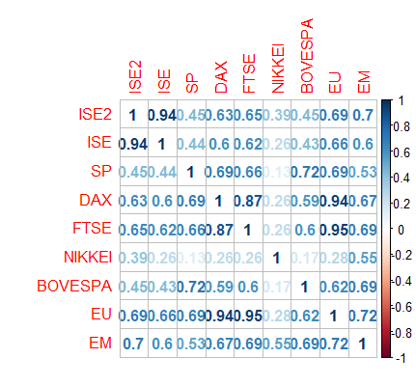

Figure:1

Figure:1, visualizes the correlation between the variables in given dataset. It is evident that all the variables have positive correlation, the relationship is linear and proves our theory of interdependency between stock-exchanges.

**Multiple Regression:**

3.1 First Regression results:

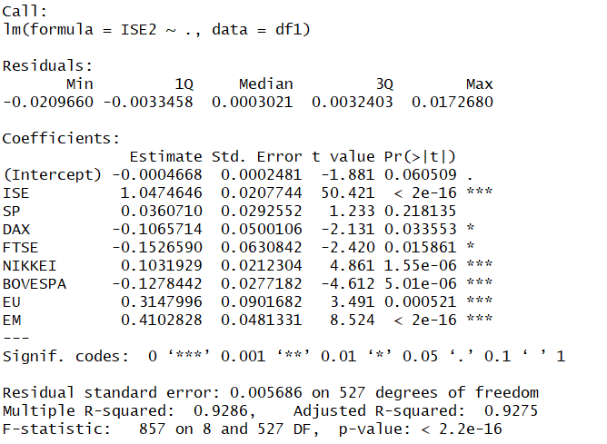

We can see that SP, DAX and FTSE are relatively insignificant for this model.

It is possible that correlations exist between our predictors. This is a condition known as multicollinearity, and this has the potential to make our results invalid.

Therefore, we test for this condition using a Variance Inflation Factor (VIF) test. If our VIF statistic > 10, then there exists an issue with multicollinearity.

The Variance Inflation Factor is calculated as follows:

**VIF = 1 /1−R 2**

Note that the R 2 is the statistic obtained from the auxiliary regression – i.e. the one where an independent variable is regressed against the other independent variables.

For FTSE and EU value is greater than 10, indicating multicollinearity.



3.2 Method – Backward Selection

To identify features that might help our analysis we use backward selection.

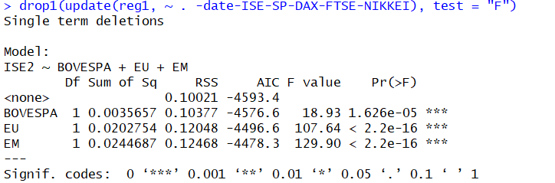

From the result of back-ward selection, we can see that this model includes all significant features according to the p-values.

To verify our results, we can again check variance inflation factor.



The VIF values are a great proof that multicollinearity is removed from the model.

3.3. Breusch-Pagan Test for Heteroscedasticity

Heteroscedasticity is a term used to describe a condition where there is an uneven variance across our error term.

Let’s take the following example. Suppose that you are conducting an analysis on incomes across the United States. Chances are, you will find that incomes in New York are significantly higher than in North Dakota. Given that major cities are likely to have higher populations and thus higher incomes, the residuals across your observations will be unevenly distributed. In this instance, you will find that the variance of your error term gets larger across cities with higher populations.

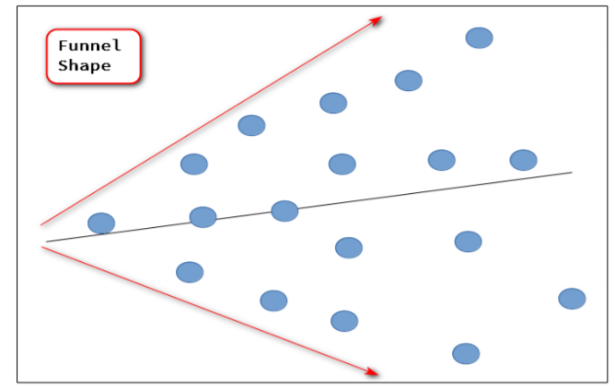

To correct for this condition, it is necessary to test for heteroscedasticity using the Breusch-Pagan test, and then remedy for the condition if it exists.

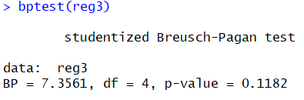

p-value is greater than 0.05, we reject the alternate hypothesis. We can conclude that this model is a proper fit for further analysis.

3.4 Outlier Test

3.4.1 Bonferonni p-value for most extreme observation.



3.4.2 Q-Q plot for studentized residuals

[1] 4 68

3.4.3 Leverage Plots

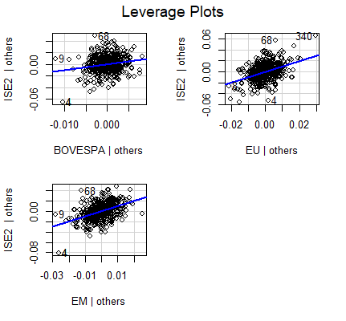

Figure:3

 The results of the least squares regression can be visualized as given in figure 3. The linear relationship

is well defined and we can see that 4, 68 are the extreme cases of outlier followed by 340,9.

3.5 Normality of Residuals

3.5.1 Distribution of studentized residuals.

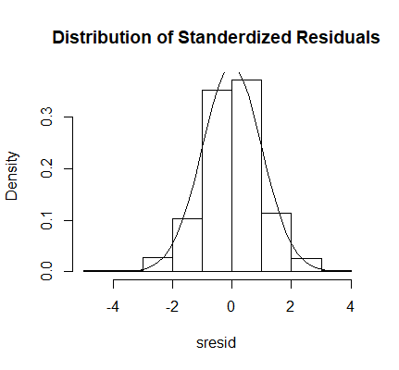

Figure:4

If we remove the outliers we can see that the distribution is normal between (-4,4).

3.5.2 QQ plot for studentized residuals

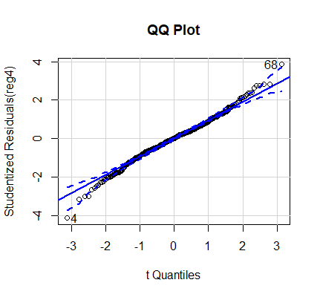

Figure:5

We can see that the error term is normally distribute in this model.

3.5.3 Non-constant Variance Score

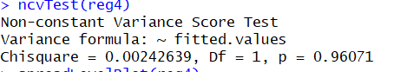

These results agree and support the Breusch-Pagan test.  The variance of the residuals is assumed to be constant (i.e. independent) over the values of the response (fitted values).

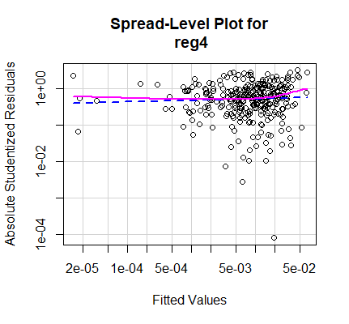

Suggested power transformation: 0.9548904

Figure:6

From figure:6 the suggested power transformation is close to 1, meaning there is no transformation required.

**RESULTS:**

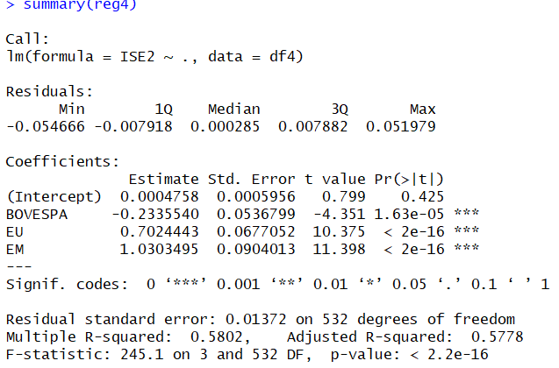

Final model is given by,

**Y = 0.00047-0.2335*BOVESPA + 0.7024EU + 1.0303*EM**

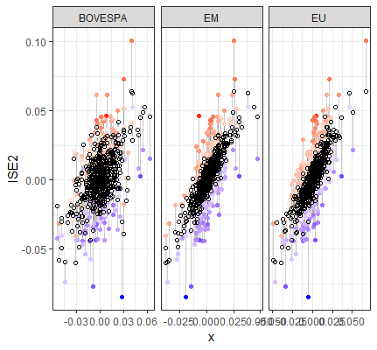Figure:7

Figure:7 is plot between predicted and residual values, the least squares regression.

**Conclusion:**

5.1 ISE and BOVESPA

ISE and BOVESPA are in different and distance regions of the world, these markets have been showing similar patterns in response to recent global crisis and their relations with the IMF have had considerable effect on their macroeconomic fundamentals as well as their stock market developments.

Both countries are classified as emerging markets and have been heavily indebted to IMF, and

accordingly, have been implementing IMF-backed stabilization programs. The mentioned markets have also similar economic histories. The liquidity crises led to major devaluations which resulted in the free

flow at of respective exchange rates.

Since then Brazil stock market has been closely followed by traders in Istanbul Stock Exchange and has been considered to contain information on the direction of global liquidity.

Thus, the nature of this relationship needs to be analyzed for portfolio diversification opportunities.

5.2 ISE and MSCI emerging markets(EM)

MSCI emerging markets index and ISE are supposed to be related as it gives the maximum contribution

to ISE.  Turkish equities represent less than 1 percent of the MSCI Emerging Markets Index. Even with

the country’s equity market down by 51 percent in dollar terms since the start of 2018, that alone has

little impact on diversified equity investors. On the contrary in Aug’2018 when Turkish economic crisis occurred EM did take a hit showing that EM equities are correlated specially during currency/economic crises even when the country in question has a nominally low weighting.

**Future Scope:**

1.Time series analysis of the data to understand the pattern of stock movements and predict the stock-returns.

2. Expand the dataset from new resources to add more important macro-economic features that might play an important role in stock-returns of the market.

3.Relationship between MSCI Europe Index and Istanbul Stock exchange is not very clear. Expand the research to find evidence and support this relationship better.